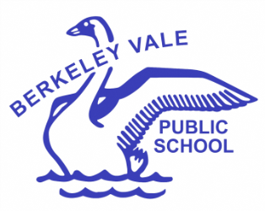
Learning to Live

Berkeley Vale Public School

Special Religious Education Participation Letter
Dear parent/carer,
A feature of the public education system in NSW is the opportunity to provide time in class for education in ethics, faith and morality from a religious or non-religious perspective at the choice of parents.
The school website https://berkeleyva-p.schools.nsw.gov.au/ provides information on these options to support parent/carer choice.
A parent/carer may at any time notify the school in writing that they wish to change their decision. Students will continue the same arrangement as the previous year, unless a parent/carer has requested a change in writing.
For more information about Special Religious Education (SRE), including the list of approved providers, please visit: https://education.nsw.gov.au/teaching-and-learning/curriculum/learning-across-the-curriculum/religion-and-ethics
If your preferred SRE option is not available please contact the approved provider. Students not attending SRE are given supervised alternative meaningful activities.
The following options are available at Berkeley Vale Public School. Please choose one.
SRE Options
□ Option 1: Combined Arrangement Scripture (provided by EV Church Erina, Condell Park Bible Church, The Lakes Evangelical Church, Baptist Union of NSW).
□ Option 2: Catholic Scripture (provided by Catholic Diocese of Broken Bay).
OR
□ Please check this box if you do not wish for your child to attend SRE. Your child will participate in alternative meaningful activities.
Student name: Year:
Signature of parent/carer: Date:

